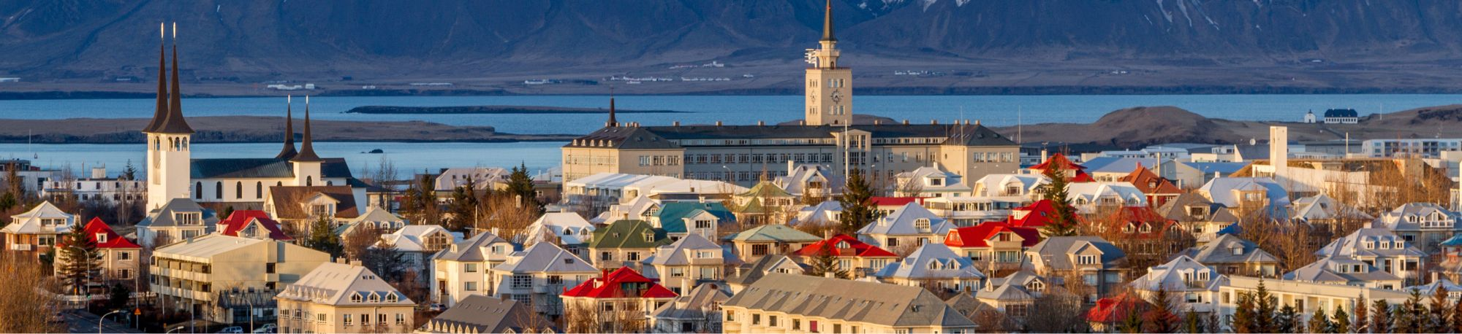

Iceland Trip – 6 Days
Travelers: 2 adults
Dates: 7/18/2X - 7/22/2X (6 days/5 nights)
Air: Arrive Reykjavik (7/19/2X), depart Reykjavik (7/22/2X)
Locations Include:
• Reykjavik
• Hveragardi
• Near Jokulsarlon Glacier

Day | Day of the Week | Activities | Location(s) & Notes
Day 1 | Tuesday  July 18, 202X | - Flight: 915P United flight (UA912) from ORD, arrive 830A to Reykjavik (KEF)Airports: ORD>KEF (6h 15m) | - Airports: ORD>KEF (6h 15m)  - Overnight flight
Day 2 | Wednesday  July 19, 202X | - Flight: Arrive 830A into Reykjavik (KEF)  - Transfer: 9:30A reserved transport from the airport (KEF) to the Blue Lagoon  - Activity: 10A pre-paid premium admittance for 2 to hot springs (Booking #WBL01232049)  - Transfer: 1:15P reserved transport to bus stop #3 (closest to the hotel)  - Hotel: Check in to City Center Hotel Reykjavik  - Activity: Explore Reykjavik (see saved Google Maps places)  - Dinner: 630P reservation for Reykjavik Kitchen (Address: Rauðarárstígur 8) | - Airports: Arrival at KEF  - Hotel: City Center Hotel Reykjavik  - Location(s): Blue Lagoon > Reykjavik
Day 3 | Thursday  July 20, 202X | - Hotel: Check out of City Center Hotel Reykjavik  - Activity/Tour: 830A pick up from bus stop #1/City Hall (4 min walk) for Nice Travel: 3 Day Golden Circle & Wonders of the South Tour  - Activity/Tour: Golden Circle: Thingvellir National Park > Geysir & Haukadalur Geothermal Area > Gullfoss (Golden) Waterfall > Kerid Volcanic Crater > Hveragerdi (overnight stay)  - Hotel: Check-in TBD tour hotel assigned by Nice Travel in Hveragerdi | - Hotel: TBD Tour Hotel  - Tour: Nice Travel 3 Day Golden Circle & Wonders of the South Tour  - Location(s): Reykjavik > Hveragerdi
Day 4 | Friday  July 21, 202X | - Hotel: Check out of the TBD tour hotel assigned by Nice Travel in Hveragerdi  - Activity/Tour: Seljalandsfoss and Gljúfrabúi waterfalls (short walk) > Skógafoss waterfall (climb stairs) > Sólheimajökull glacier > Dyrhólaey (southernmost peninsula/puffin colonies) > Reynisfjara (black sand beach) > near Jokulsarlon Glacier  - Hotel: Check-in TBD tour hotel assigned by Nice Travel near Jokulsarlon Glacier | - Hotel: TBD Tour hotel  - Tour: Nice Travel 3 Day Tour  - Location(s): Hveragerdi > near Jokulsarlon Glacier  - Included: Breakfast (at TBD hotel)
Day 5 | Saturday  July 22, 202X | - Hotel: Check out of the TBD tour hotel near Jokulsarlon Glacier  - Activity/Tour: Diamond Beach & Jokulsarlon Glacier Lagoon > amphibious boat tour > Fjadrargljufur (river canyon) > Vik Village > Reykjavik  - Activity/Tour: Return to Reykjavik around 8P  - Hotel: Check in to City Center Hotel Reykjavik | - Hotel: City Center Hotel Reykjavik  - Tour: Nice Travel 3 Day Tour  - Location(s): Near Jokulsarlon Glacier > Reykjavik  - Included: Breakfast (at TBD hotel)
Day 6 | Sunday  July 23, 202X | - Hotel: Check out to City Center Hotel Reykjavik  - Transfer: Book a taxi with the hotel on arrival, or buy advance tickets for Flybus (for bus stop #3 pick-up)  - Flight: 1200P United flight (UA913) from KEF, arrive 145P to Chicago (ORD) | - Airports: KEF>ORD (6h 45m)

